<https://us1.ca.analytics.ibm.com/bi/?perspective=explore&pathRef=.my_folders%2FNew%2Bexploration%2B1.0&subView=model000001837d45ee3b_00000004>

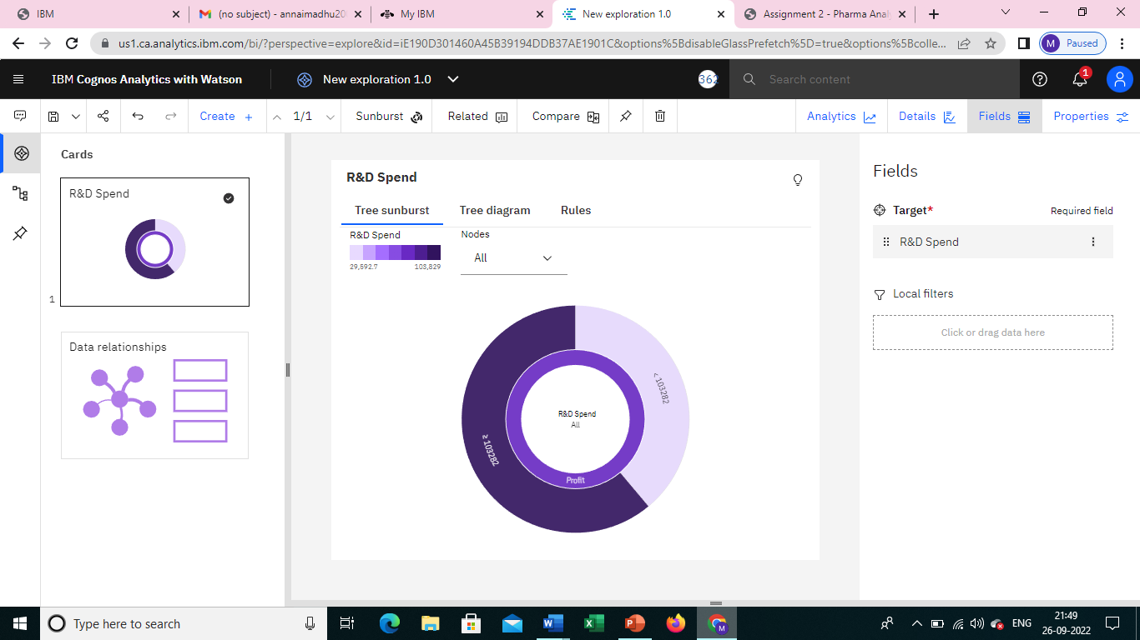

<https://us1.ca.analytics.ibm.com/bi/?perspective=explore&pathRef=.my_folders%2FNew%2Bexploration%2B2.0&subView=model000001837d47a298_00000000>

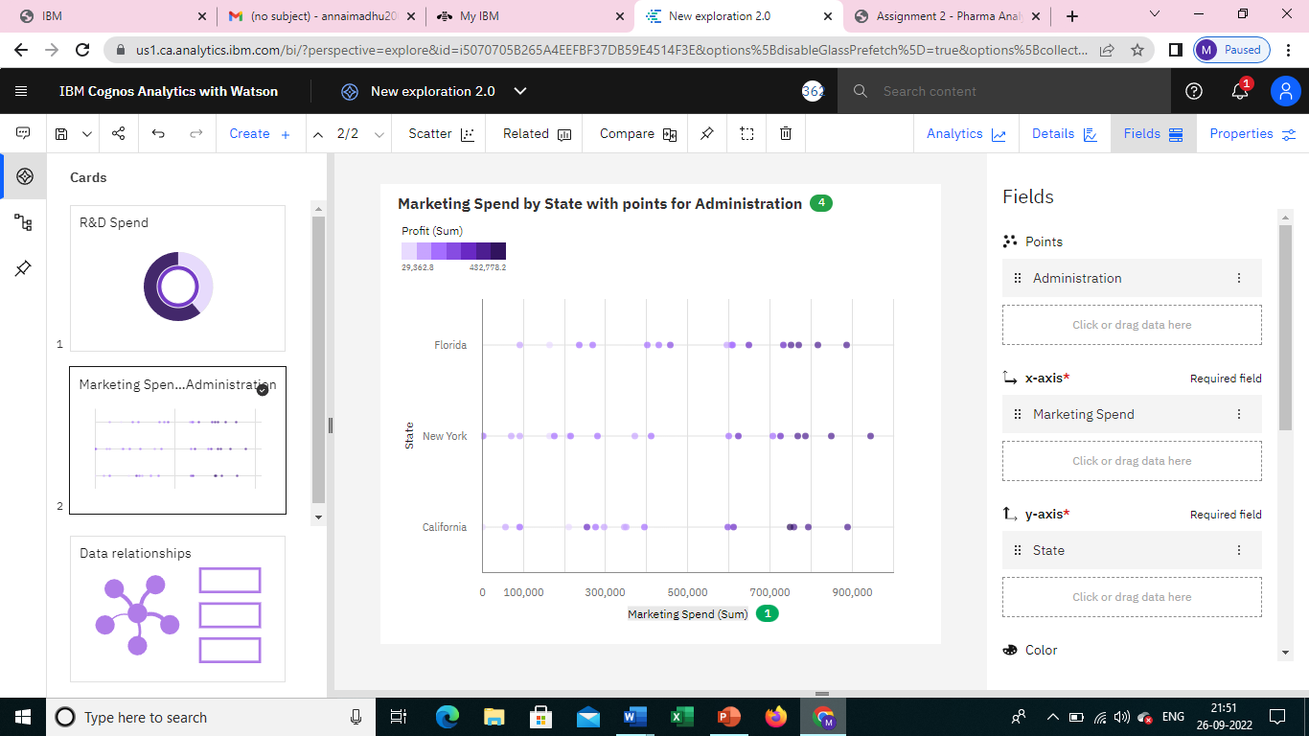

<https://us1.ca.analytics.ibm.com/bi/?perspective=explore&pathRef=.my_folders%2FNew%2Bexploration%2B3&subView=model000001837d49390f_00000000>

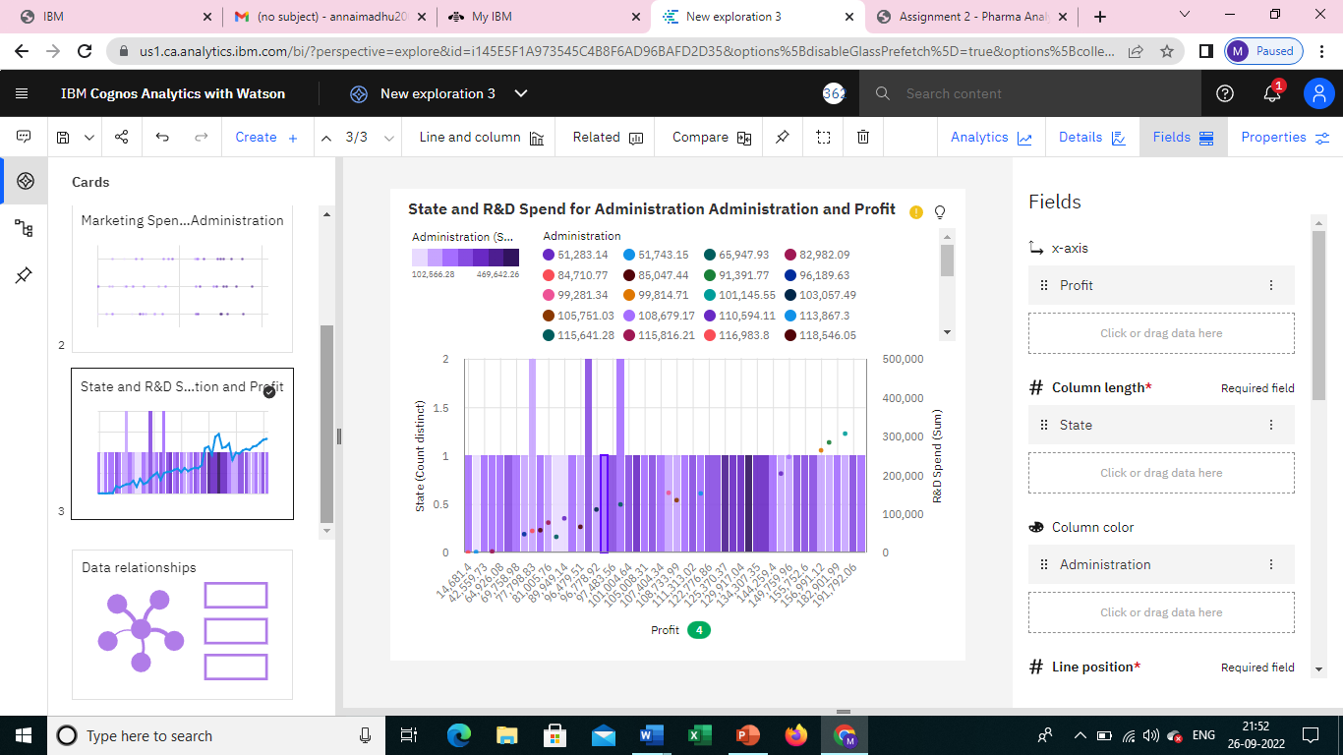

<https://us1.ca.analytics.ibm.com/bi/?perspective=explore&pathRef=.my_folders%2FNew%2Bexploration%2B4&subView=model000001837d4ad982_00000003>

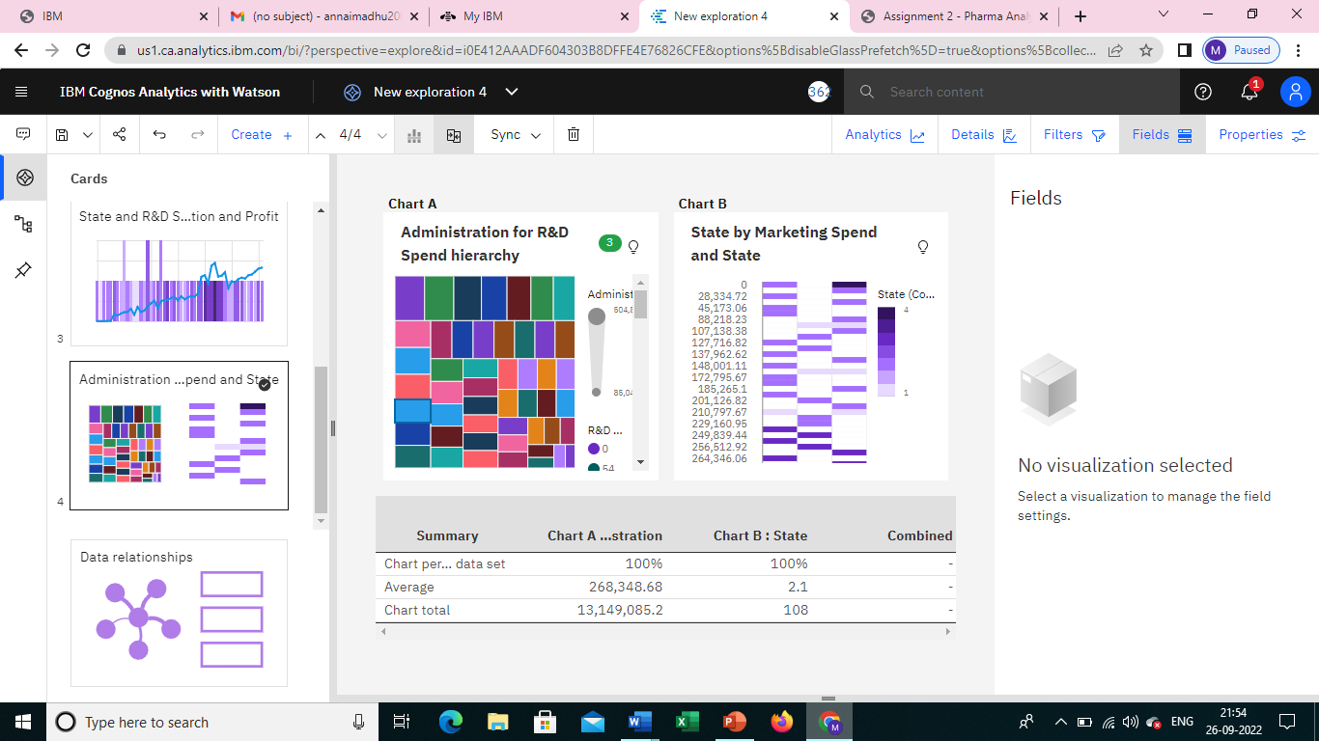

<https://us1.ca.analytics.ibm.com/bi/?perspective=explore&pathRef=.my_folders%2FNew%2Bexploration%2B5&subView=model000001837d4c80df_00000000>

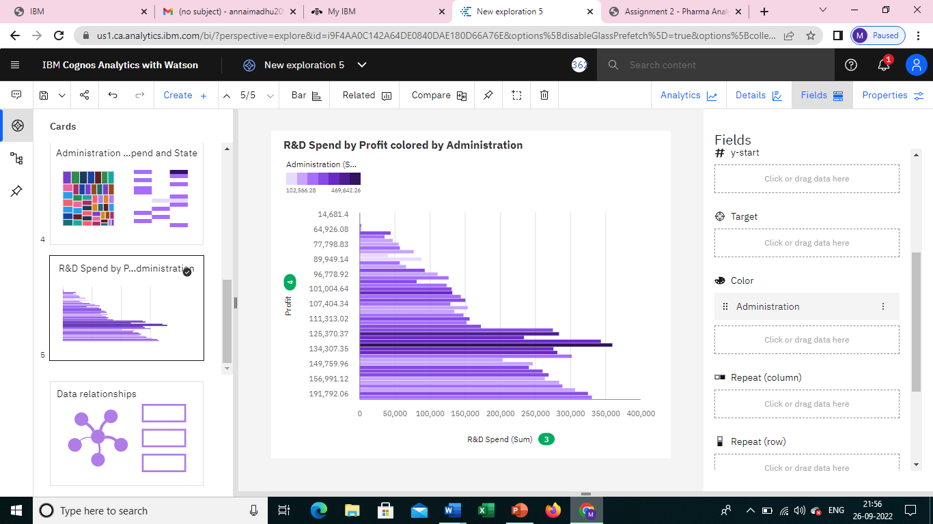

<https://us1.ca.analytics.ibm.com/bi/?perspective=explore&pathRef=.my_folders%2FNew%2Bexploration%2B6&subView=model000001837d4dc314_00000000>

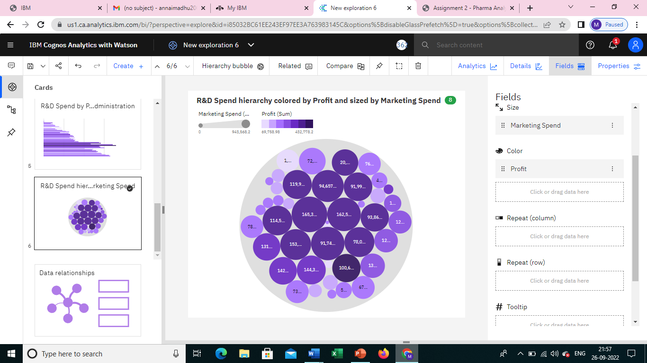

<https://us1.ca.analytics.ibm.com/bi/?perspective=explore&pathRef=.my_folders%2FNew%2Bexploration%2B7&subView=model000001837d4f04cf_00000003>

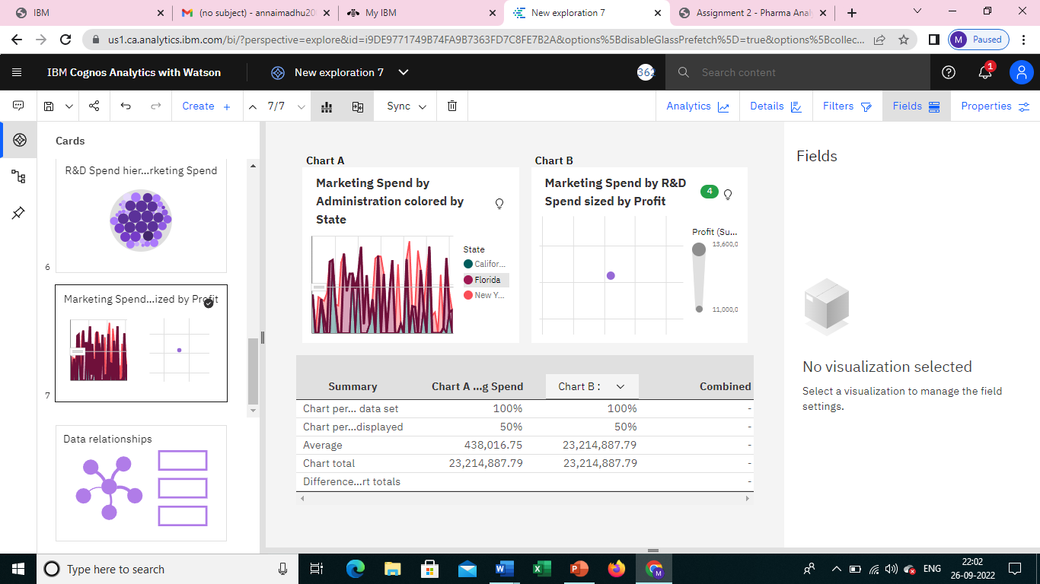

<https://us1.ca.analytics.ibm.com/bi/?perspective=explore&pathRef=.my_folders%2FNew%2Bexploration%2B8&subView=model000001837d5370a2_00000000>

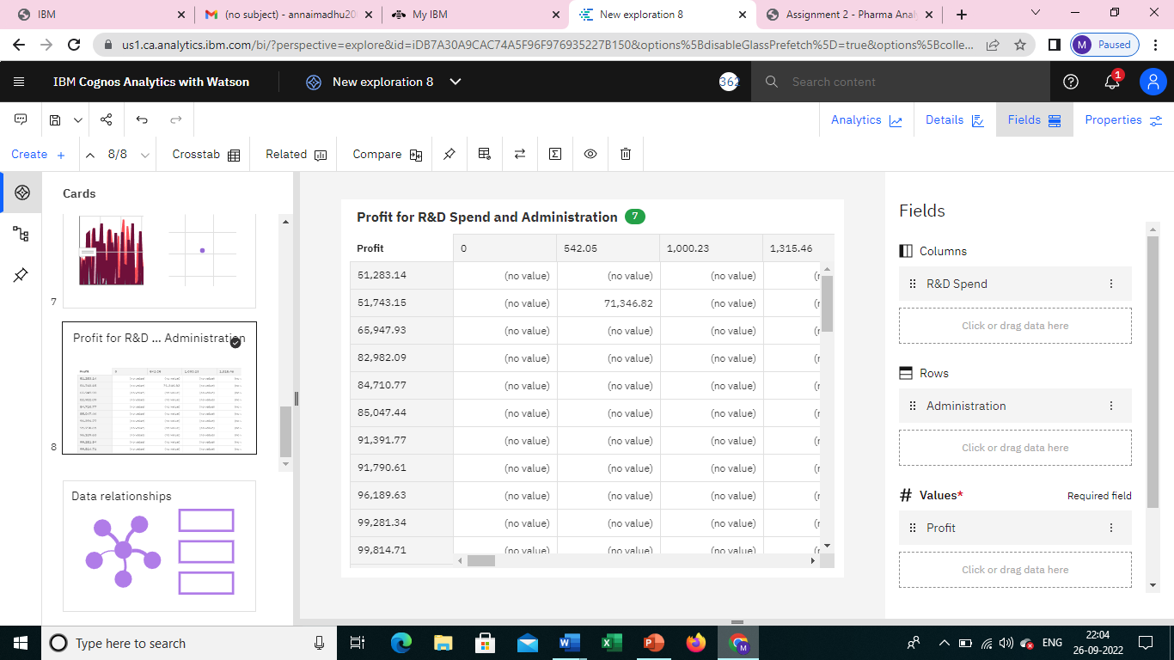

<https://us1.ca.analytics.ibm.com/bi/?perspective=explore&pathRef=.my_folders%2FNew%2Bexploration%2B9&subView=model000001837d54e5b7_00000004>

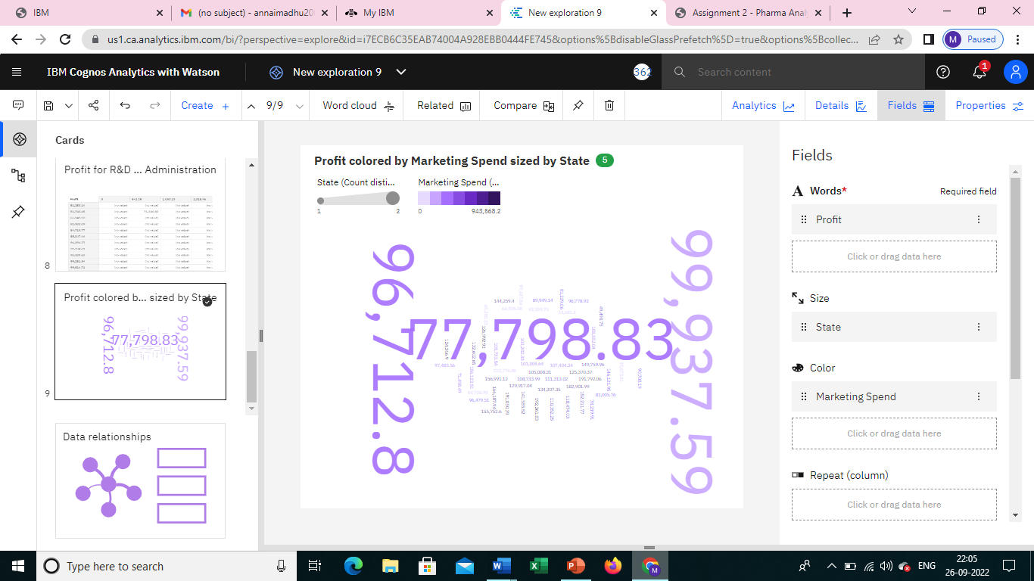

<https://us1.ca.analytics.ibm.com/bi/?perspective=explore&pathRef=.my_folders%2FNew%2Bexploration%2B10&subView=model000001837d5668d9_00000003>

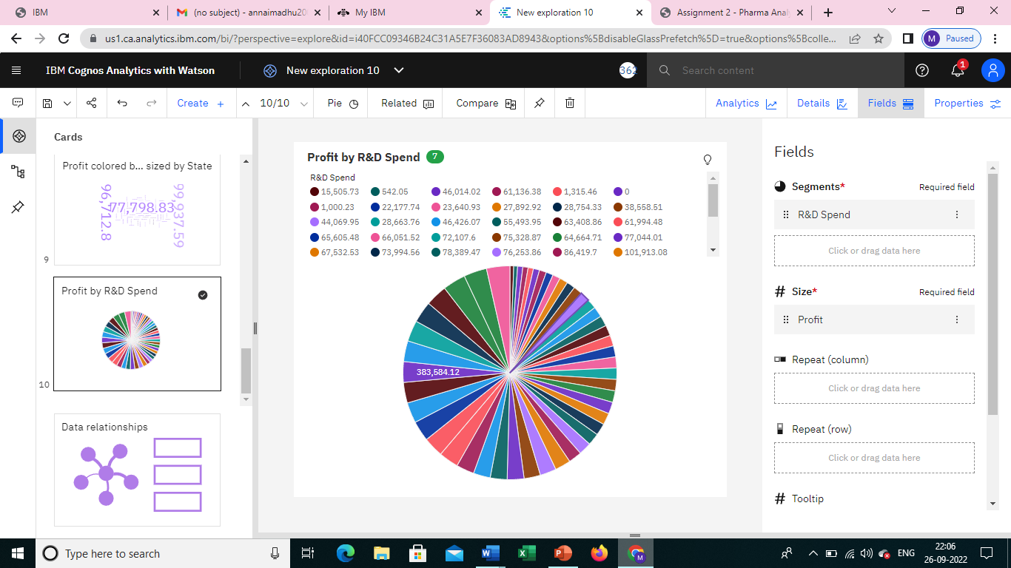

<https://us1.ca.analytics.ibm.com/bi/?perspective=explore&pathRef=.my_folders%2FNew%2Bexploration%2B11&subView=model000001837d5773a3_00000004>

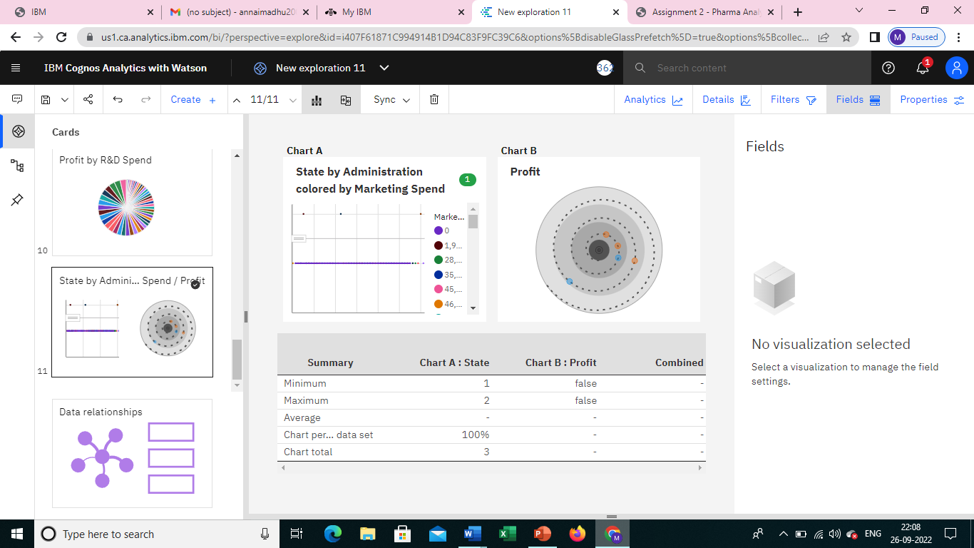

<https://us1.ca.analytics.ibm.com/bi/?perspective=explore&pathRef=.my_folders%2FNew%2Bexploration%2B12&subView=model000001837d596018_00000000>

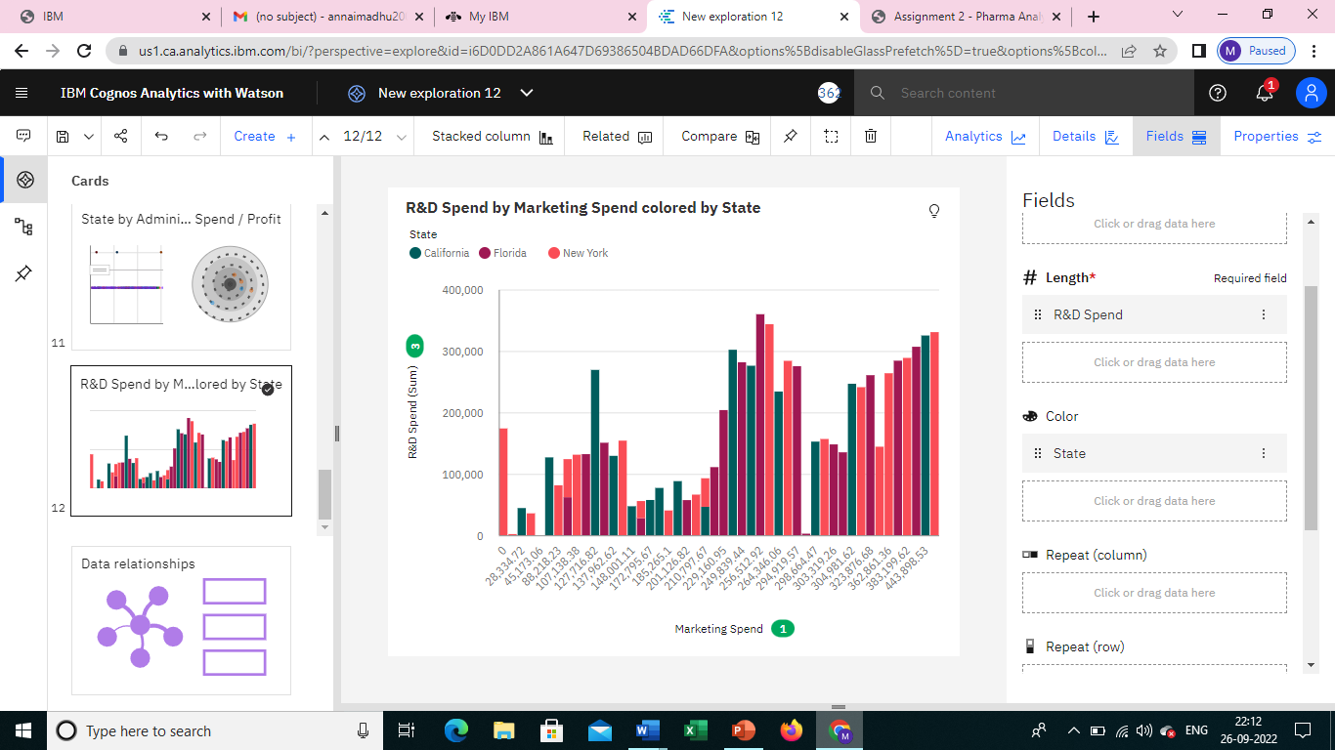

<https://us1.ca.analytics.ibm.com/bi/?perspective=explore&pathRef=.my_folders%2FNew%2Bexploration%2B13&subView=model000001837d5c3b2f_00000000>

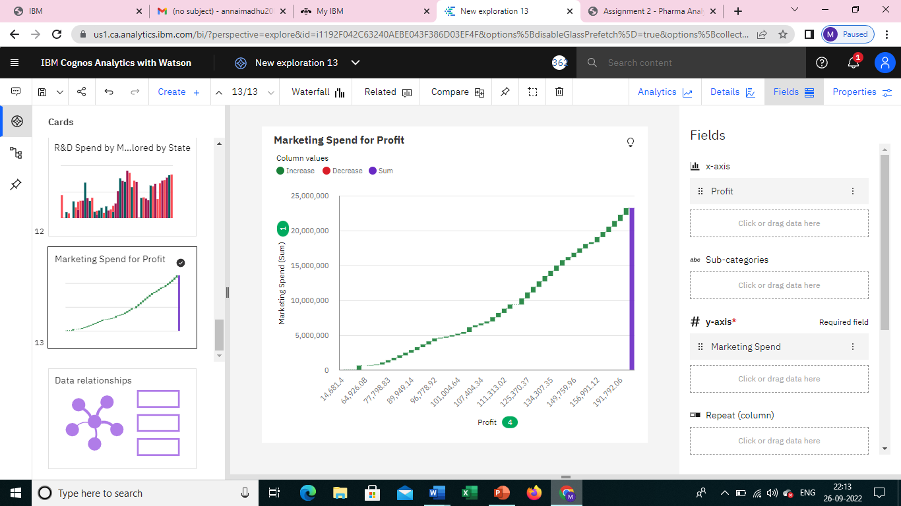

<https://us1.ca.analytics.ibm.com/bi/?perspective=explore&pathRef=.my_folders%2FNew%2Bexploration%2B14&subView=model000001837d5d4751_00000000>

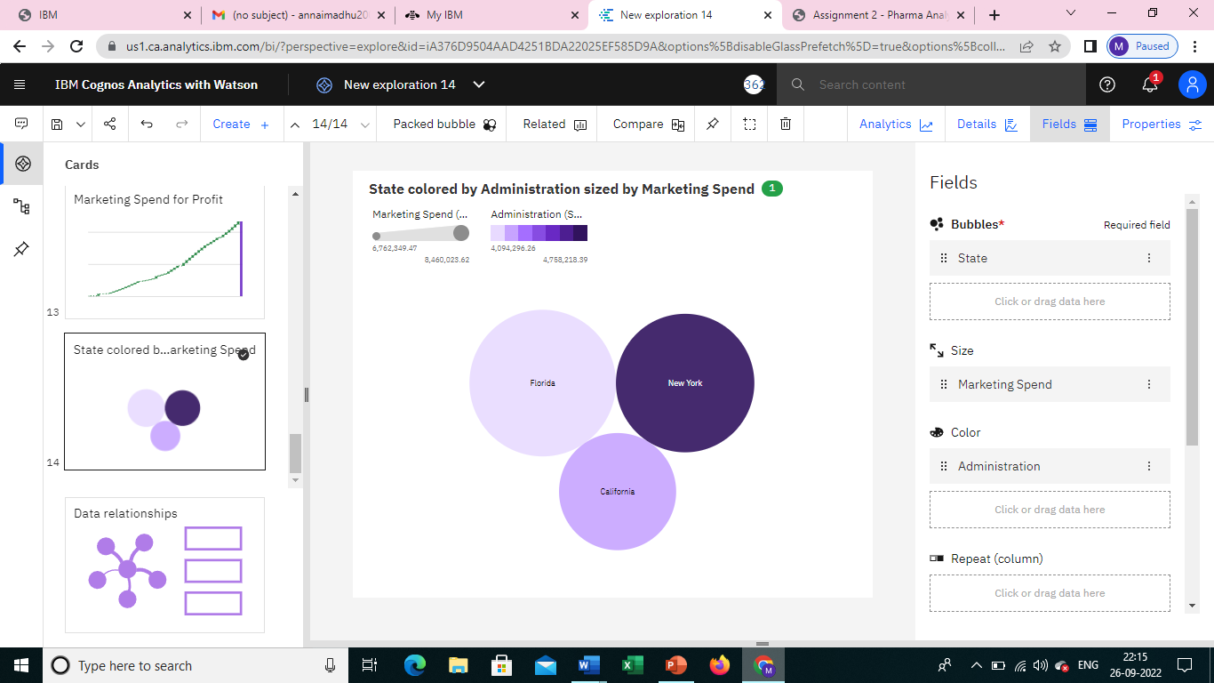

<https://us1.ca.analytics.ibm.com/bi/?perspective=explore&pathRef=.my_folders%2FNew%2Bexploration%2B15&subView=model000001837d5ef810_00000003>

